### Entity relationship diagram

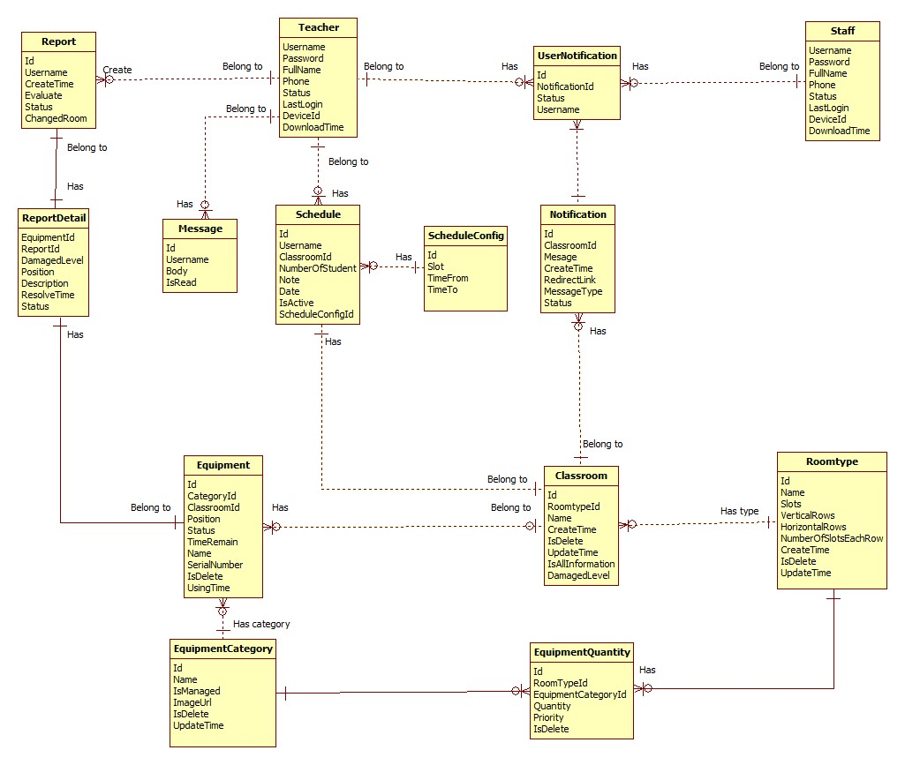

### Entity Dictionary

|  |  |
| --- | --- |
| Data Dictionary | |
| Entity name | **Description** |
| Teacher | Abstract entity describes a user with role teacher in system. |
| Staff | Abstract entity describes a user with role staff in system. |
| UserNotification | Represent a notification sent for user. |
| Notification | Contain the notification information. |
| Message | Represent a message sent by teacher. |
| Schedule | Contain the schedule information. |
| ScheduleConfig | Contain the schedule configuration information |
| Classroom | Contain the classroom information. |
| RoomType | Contain the room type information. |
| EquipmentQuantity | Contain the equipment quantity information. |
| EquipmentCategory | Contain the equipment category information. |
| Equipment | Contain the equipment information. |
| ReportDetail | Contain the report detail information. |
| Report | Contain the report information. |